Contents

* Introduction: 1

Reference GitHub repository: 1

Clone the Labs repository to local device: 1

Create Container from VsCode 3

Update Program.cs 4

Update primary key and endpoint uri in following script 4

Create Database : 6

Populate Container with Data of Different Types 11

# * Introduction:

In this Lab we would be performing following tasks:

* Create COSMODB account with PowerShell.
* Create database container and put data using PowerShell.

# Reference GitHub repository:

<https://github.com/CosmosDB/labs>

* <https://cosmosdb.github.io/labs/dotnet/labs/01-creating_partitioned_collection.html>

* <https://cosmosdb.github.io/labs/dotnet/labs/00-account_setup.html#lab-content-setup>

This repository is from Microsoft which stores PS for managing cosmoDB

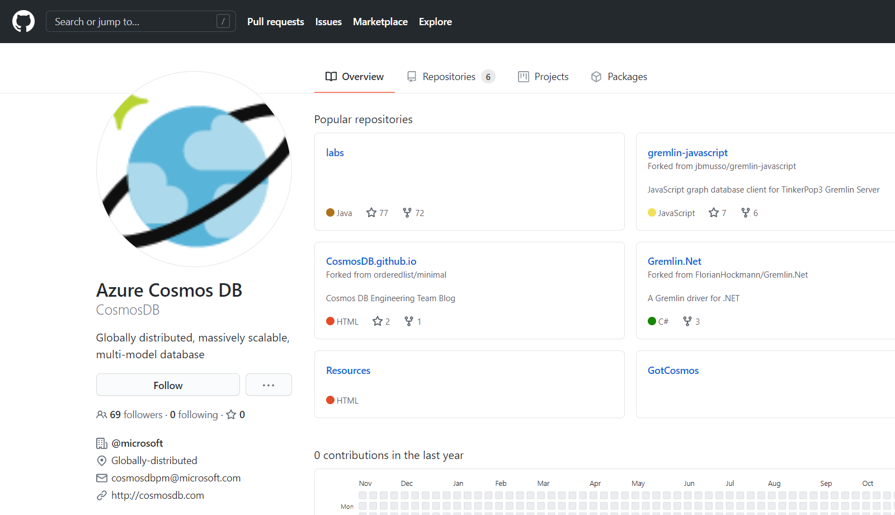

# Clone the Labs repository to local device:

Open Windows PowerShell in admin mode

md cosmodb

cd cosmodb

git clone <https://github.com/CosmosDB/labs.git>

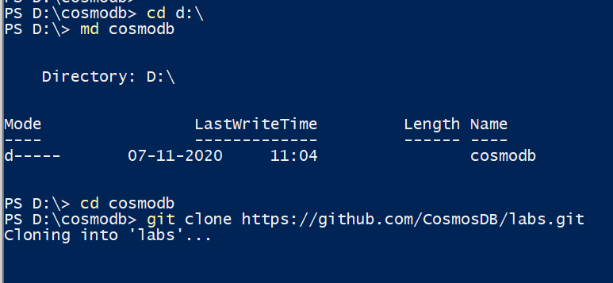

cd labs

cd .\dotnet\setup\

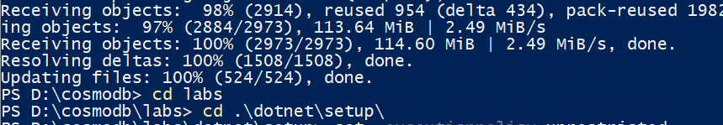

Set-ExecutionPolicy Unrestricted

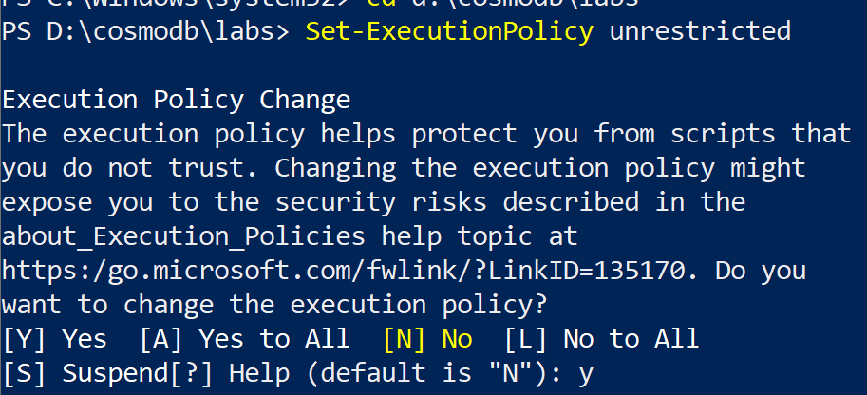

.\labCodeSetup.ps1

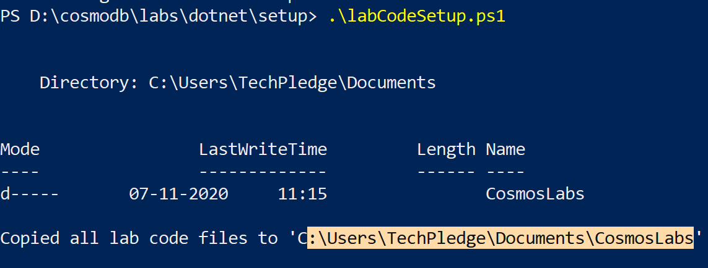

Install-Module -Name Az -AllowClobber

Connect-AzAccount

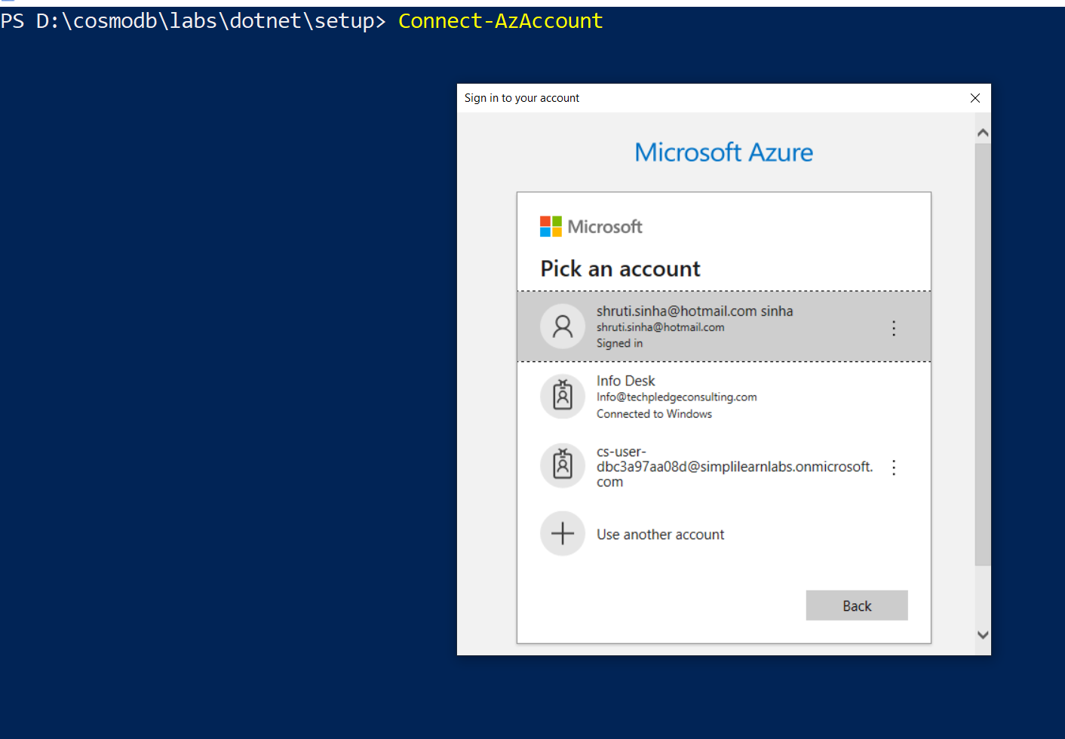

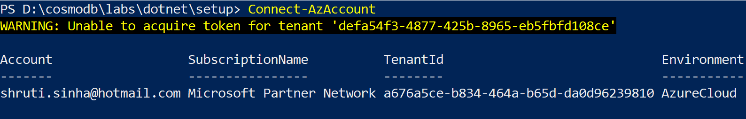

.\labSetup.ps1

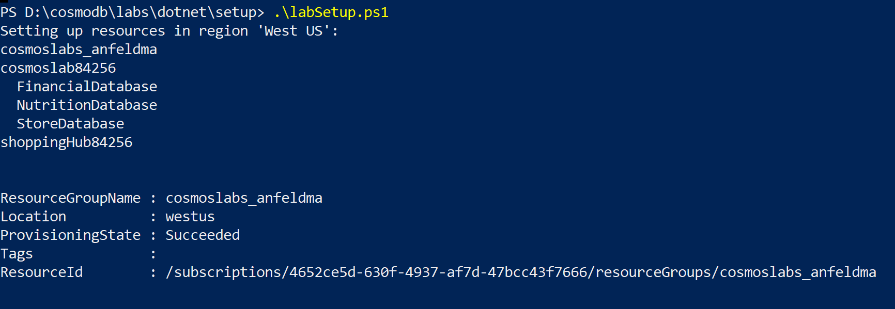

We have created a Cosmo DB account using the PS.

Now lets create container inside:

# Create Container from VsCode

open "DataTypes.cs" in VsCode from C:\Users\Admin\Documents\CosmosLabs\Lab01



in vscode terminal type

dotnet new console --output .

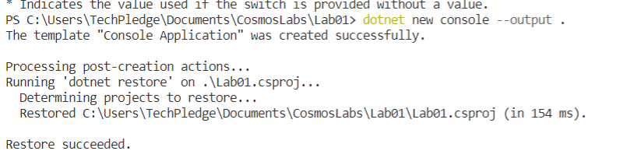

dotnet add package Microsoft.Azure.Cosmos --version 3.7.0

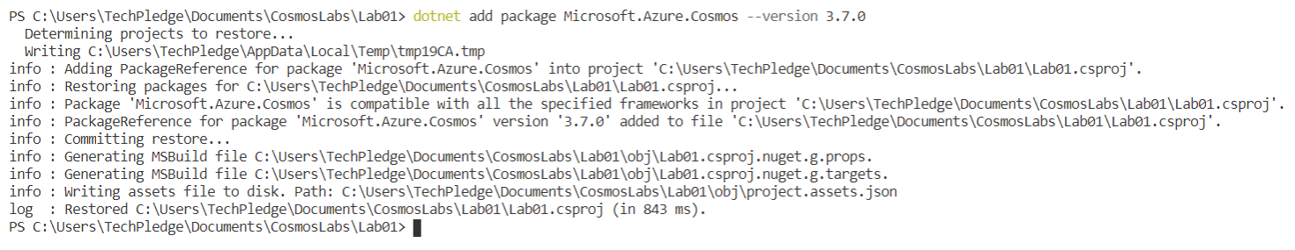

dotnet add package Bogus --version 22.0.8

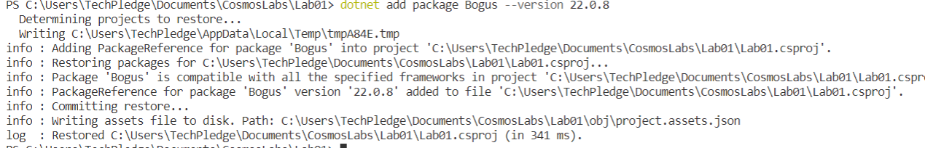

dotnet restore

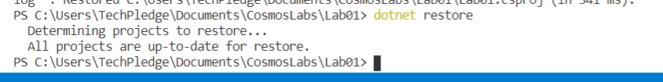

## Update Program.cs

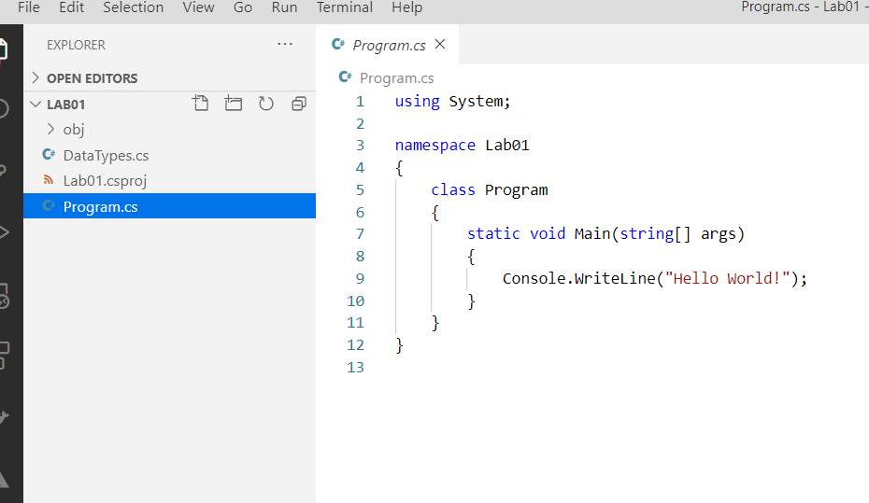

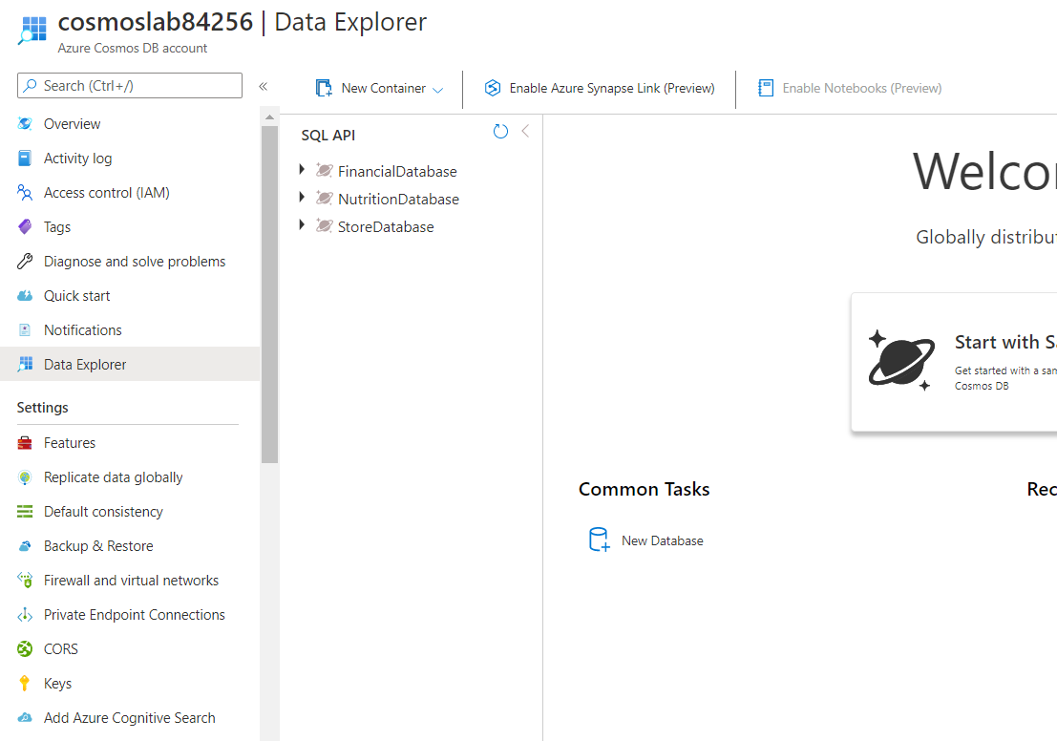

## Update primary key and endpoint uri in following script

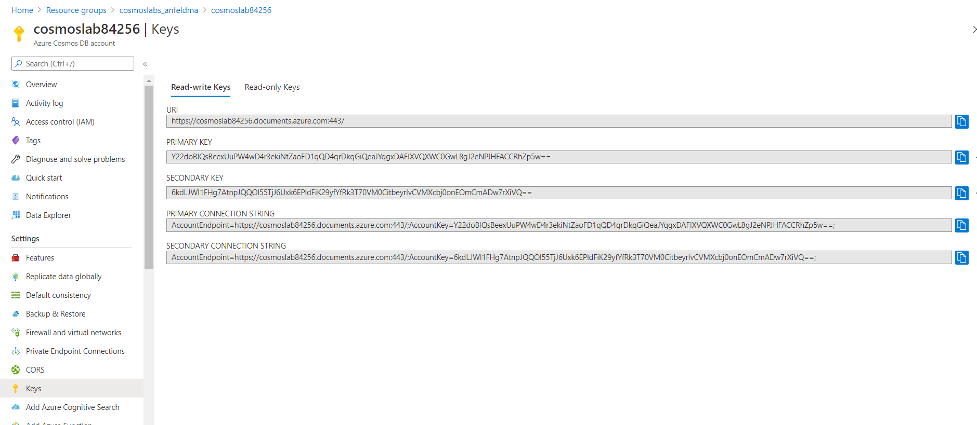

==========Program.cs=============

using System.Collections.Generic;

using System.Collections.ObjectModel;

using System.Linq;

using System.Threading.Tasks;

using Microsoft.Azure.Cosmos;

using System;

namespace Lab01

{

public class Program

{

private static readonly string _endpointUri = "https://cosmoslab22681.documents.azure.com:443/";

private static readonly string _primaryKey = "09xCU4jPjbh58KFpdkeMUefkopgUZxyMuLyq2p5rhZJ6s288TX9yJnFi07nghxNzCXT8wsRw68ERXYUJ9llNQg==";

public static async Task Main(string[] args)

{

using (CosmosClient client = new CosmosClient(_endpointUri, _primaryKey))

{

}

}

}

}

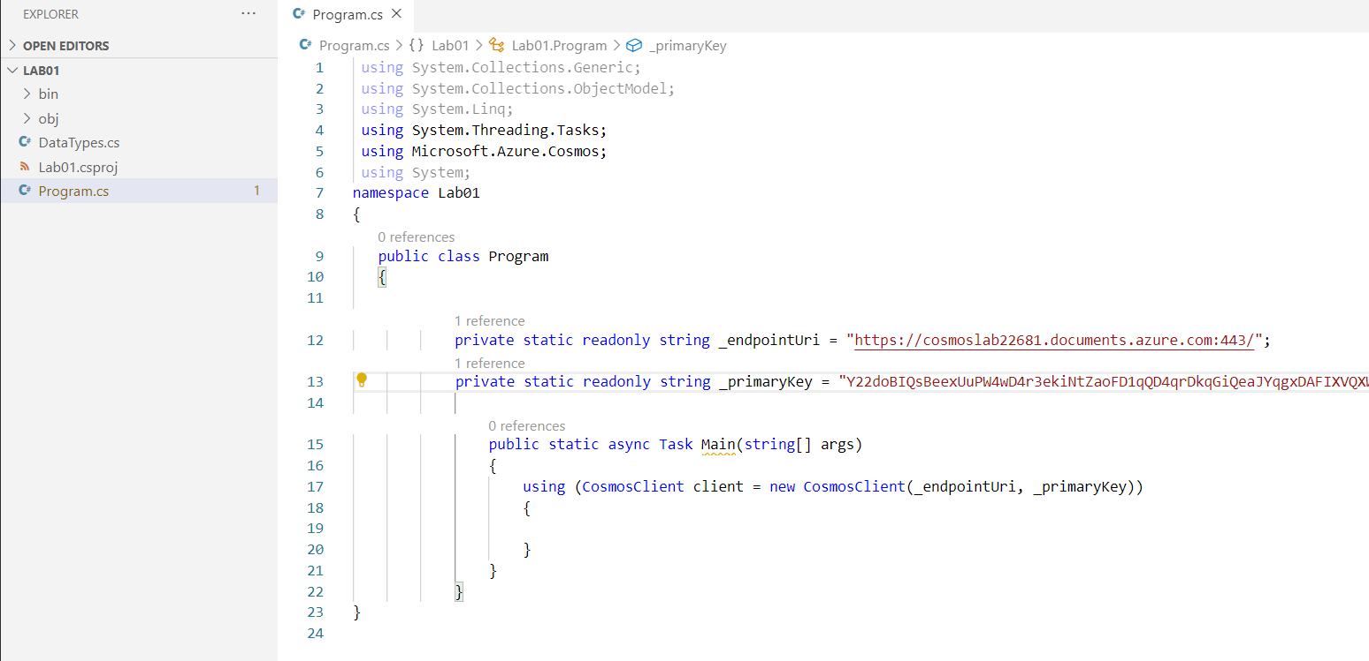

====Save the File and Run Dotnet Build ===

dotnet build

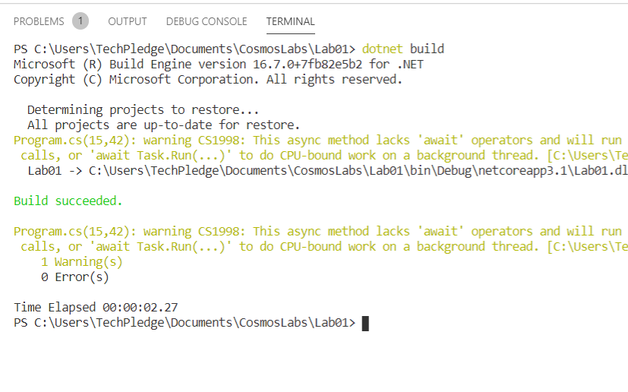

## Create Database :

=======Program.cs to Create the Database=========

using System.Collections.Generic;

using System.Collections.ObjectModel;

using System.Linq;

using System.Threading.Tasks;

using Microsoft.Azure.Cosmos;

using System;

namespace Lab01

{

public class Program

{

private static readonly string _endpointUri = "https://cosmoslab22681.documents.azure.com:443/";

private static readonly string _primaryKey = "09xCU4jPjbh58KFpdkeMUefkopgUZxyMuLyq2p5rhZJ6s288TX9yJnFi07nghxNzCXT8wsRw68ERXYUJ9llNQg==";

public static async Task Main (string[] args)

{

using (CosmosClient client = new CosmosClient(_endpointUri, _primaryKey))

{

DatabaseResponse databaseResponse = await client.CreateDatabaseIfNotExistsAsync("EntertainmentDatabase");

Database targetDatabase = databaseResponse.Database;

await Console.Out.WriteLineAsync($"Database Id:\t{targetDatabase.Id}");

}

}

}

}

===========Now Build and Run=======

Dotnet Build

Dotnet Run

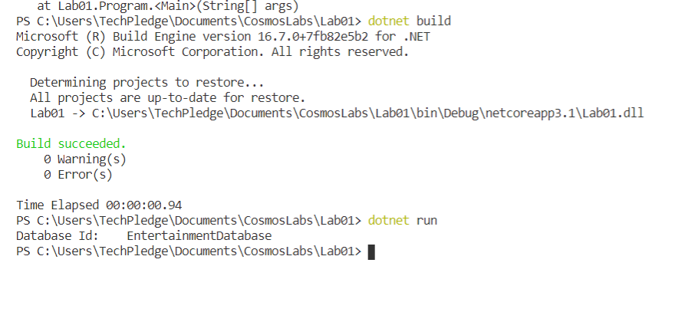

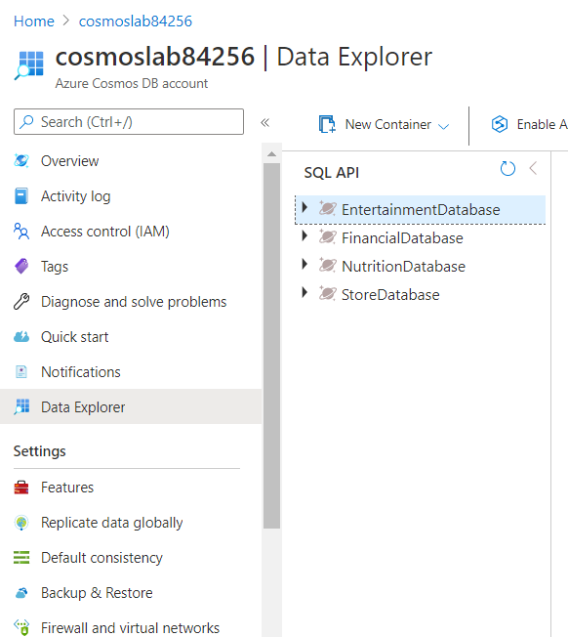

========Create a Partitioned Container using the SDK==

using System.Collections.Generic;

using System.Collections.ObjectModel;

using System.Linq;

using System.Threading.Tasks;

using Microsoft.Azure.Cosmos;

using System;

namespace Lab01

{

public class Program

{

private static readonly string _endpointUri = "https://cosmoslab22681.documents.azure.com:443/";

private static readonly string _primaryKey = "09xCU4jPjbh58KFpdkeMUefkopgUZxyMuLyq2p5rhZJ6s288TX9yJnFi07nghxNzCXT8wsRw68ERXYUJ9llNQg==";

public static async Task Main (string[] args)

{

using (CosmosClient client = new CosmosClient(_endpointUri, _primaryKey))

{

// DatabaseResponse databaseResponse = await client.CreateDatabaseIfNotExistsAsync("EntertainmentDatabase");

//Database targetDatabase = databaseResponse.Database;

// await Console.Out.WriteLineAsync($"Database Id:\t{targetDatabase.Id}");

Database targetDatabase = client.GetDatabase("EntertainmentDatabase");

IndexingPolicy indexingPolicy = new IndexingPolicy

{

IndexingMode = IndexingMode.Consistent,

Automatic = true,

IncludedPaths =

{

new IncludedPath

{

Path = "/*"

}

}

};

var containerProperties = new ContainerProperties("CustomCollection", "/type")

{

IndexingPolicy = indexingPolicy

};

var containerResponse = await targetDatabase.CreateContainerIfNotExistsAsync(containerProperties, 10000);

var customContainer = containerResponse.Container;

await Console.Out.WriteLineAsync($"Custom Container Id:\t{customContainer.Id}");

}

}

}

}

dotnet run

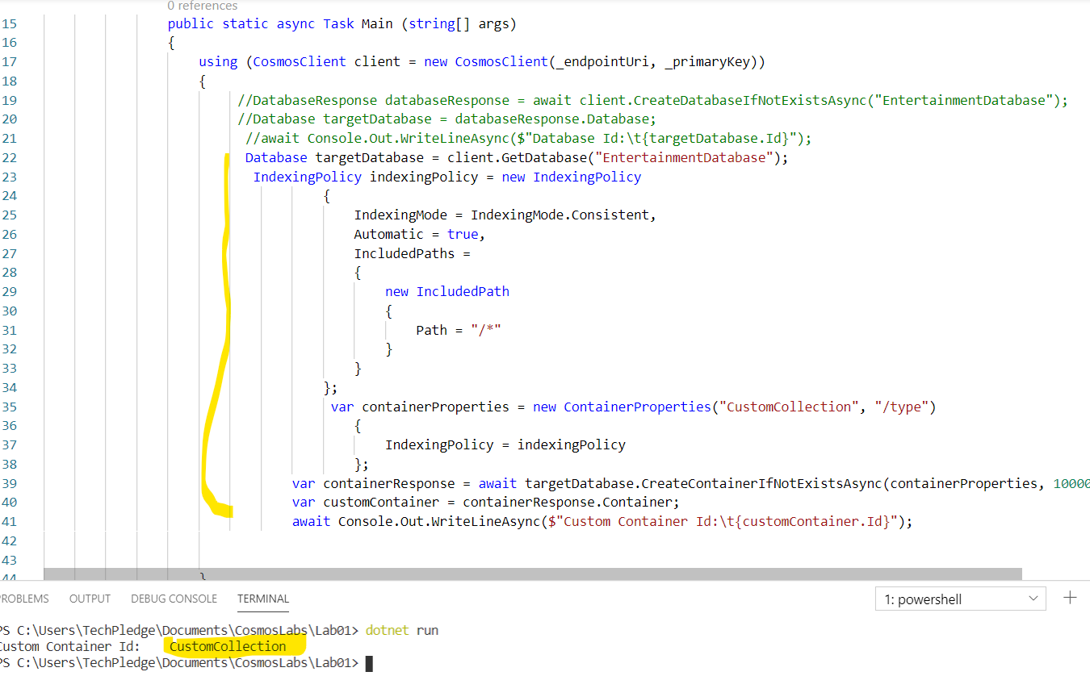

Observe changes on Azure Cosmodb account

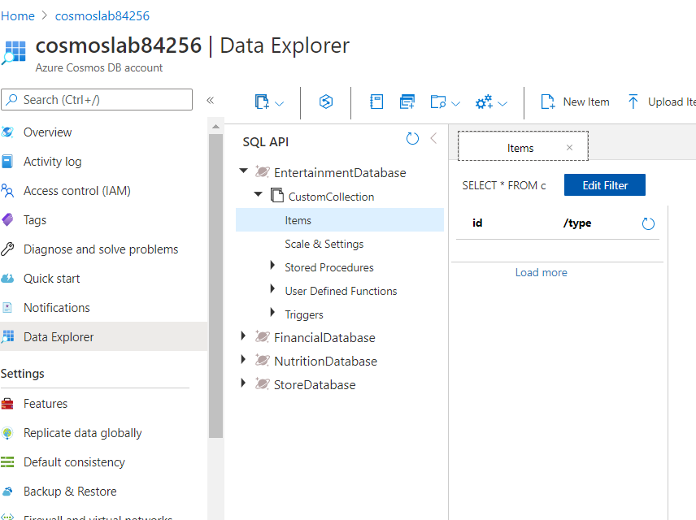

# Populate Container with Data of Different Types

using System.Collections.Generic;

using System.Collections.ObjectModel;

using System.Linq;

using System.Threading.Tasks;

using Microsoft.Azure.Cosmos;

using System;

namespace Lab01

{

public class Program

{

private static readonly string _endpointUri = "https://cosmoslab22681.documents.azure.com:443/";

private static readonly string _primaryKey = "09xCU4jPjbh58KFpdkeMUefkopgUZxyMuLyq2p5rhZJ6s288TX9yJnFi07nghxNzCXT8wsRw68ERXYUJ9llNQg==";

public static async Task Main (string[] args)

{

/* using (CosmosClient client = new CosmosClient(_endpointUri, _primaryKey))

{

// DatabaseResponse databaseResponse = await client.CreateDatabaseIfNotExistsAsync("EntertainmentDatabase");

//Database targetDatabase = databaseResponse.Database;

// await Console.Out.WriteLineAsync($"Database Id:\t{targetDatabase.Id}");

//Database targetDatabase = client.GetDatabase("EntertainmentDatabase");

/* IndexingPolicy indexingPolicy = new IndexingPolicy

{

IndexingMode = IndexingMode.Consistent,

Automatic = true,

IncludedPaths =

{

new IncludedPath

{

Path = "/*"

}

}

};

var containerProperties = new ContainerProperties("CustomCollection", "/type")

{

IndexingPolicy = indexingPolicy

};

var containerResponse = await targetDatabase.CreateContainerIfNotExistsAsync(containerProperties, 10000);

var customContainer = containerResponse.Container;

await Console.Out.WriteLineAsync($"Custom Container Id:\t{customContainer.Id}");*/

/* var targetDatabase = client.GetDatabase("EntertainmentDatabase");

var customContainer = targetDatabase.GetContainer("CustomCollection");

var foodInteractions = new Bogus.Faker<PurchaseFoodOrBeverage>()

.RuleFor(i => i.id, (fake) => Guid.NewGuid().ToString())

.RuleFor(i => i.type, (fake) => nameof(PurchaseFoodOrBeverage))

.RuleFor(i => i.unitPrice, (fake) => Math.Round(fake.Random.Decimal(1.99m, 15.99m), 2))

.RuleFor(i => i.quantity, (fake) => fake.Random.Number(1, 5))

.RuleFor(i => i.totalPrice, (fake, user) => Math.Round(user.unitPrice * user.quantity, 2))

.GenerateLazy(500);

foreach(var interaction in foodInteractions)

{

ItemResponse<PurchaseFoodOrBeverage> result = await customContainer.CreateItemAsync(interaction);

await Console.Out.WriteLineAsync($"Document [PurchaseFoodOrBeverage] Created\t{result.Resource.id}");

}*/

using (CosmosClient client = new CosmosClient(_endpointUri, _primaryKey))

{

var targetDatabase = client.GetDatabase("EntertainmentDatabase");

var customContainer = targetDatabase.GetContainer("CustomCollection");

var tvInteractions = new Bogus.Faker<WatchLiveTelevisionChannel>()

.RuleFor(i => i.id, (fake) => Guid.NewGuid().ToString())

.RuleFor(i => i.type, (fake) => nameof(WatchLiveTelevisionChannel))

.RuleFor(i => i.minutesViewed, (fake) => fake.Random.Number(1, 45))

.RuleFor(i => i.channelName, (fake) => fake.PickRandom(new List<string> { "NEWS-6", "DRAMA-15", "ACTION-12", "DOCUMENTARY-4", "SPORTS-8" }))

.GenerateLazy(500);

foreach(var interaction in tvInteractions)

{

ItemResponse<WatchLiveTelevisionChannel> result = await customContainer.CreateItemAsync(interaction);

await Console.Out.WriteLineAsync($"Document [WatchLiveTelevisionChannel] Created\t{result.Resource.id}");

}

}

}

}

}

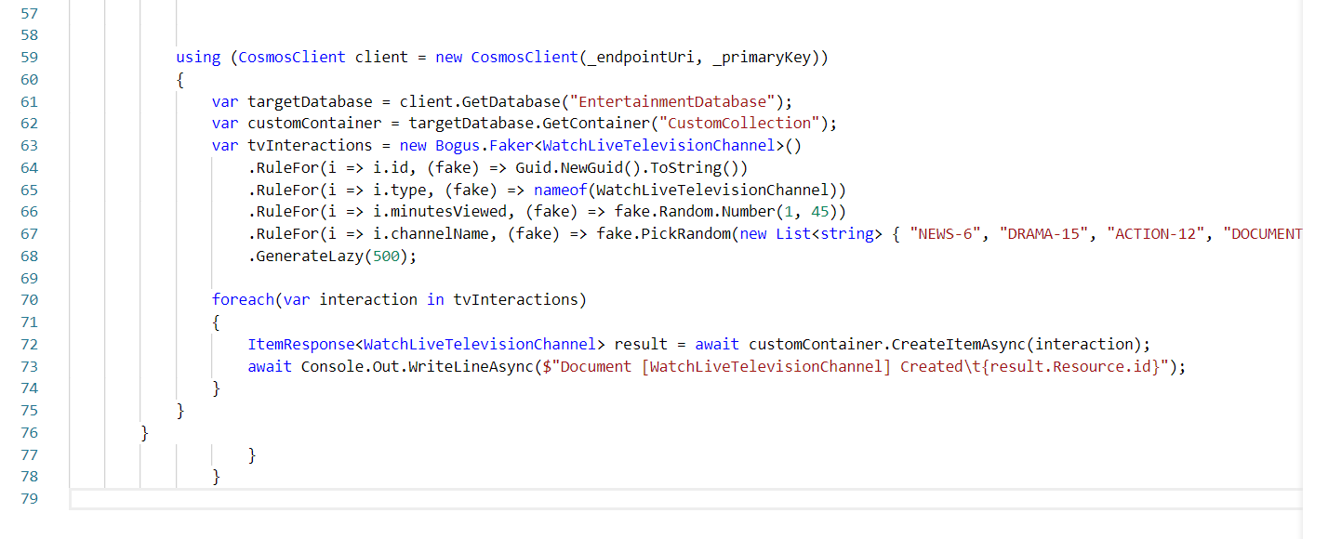

dotnet run

